SVCR GOVERNMENT DEGREE COLLEGE, PALAMANER
IQAC – PARENT'S FEED BACK 2025-26
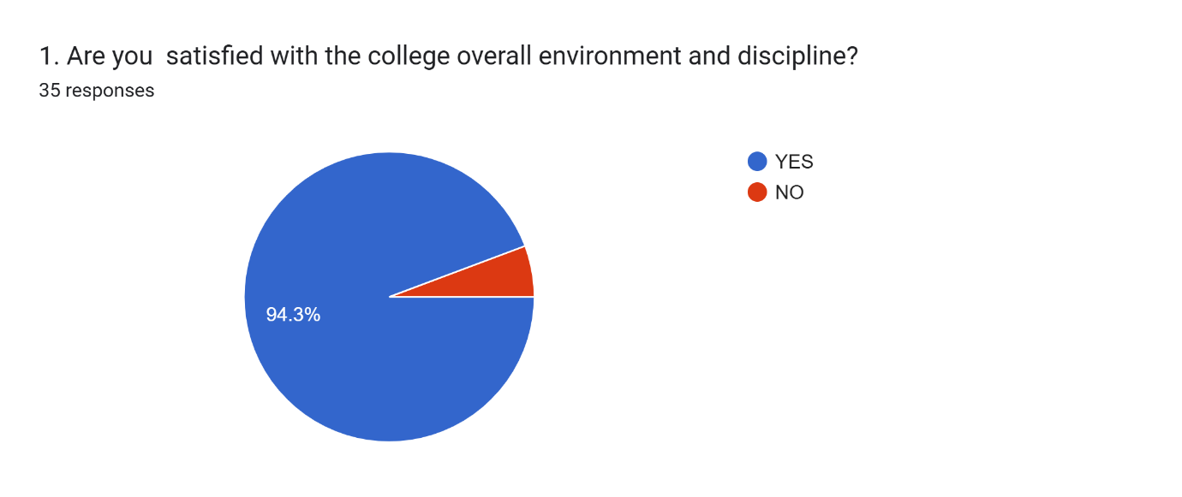
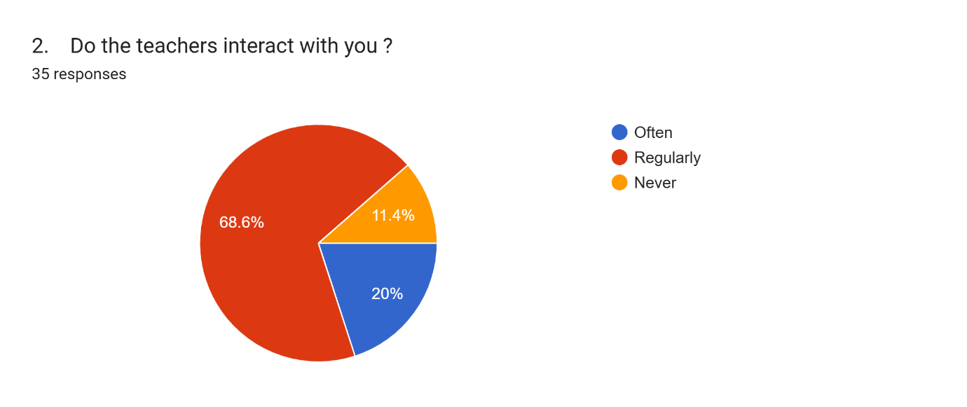
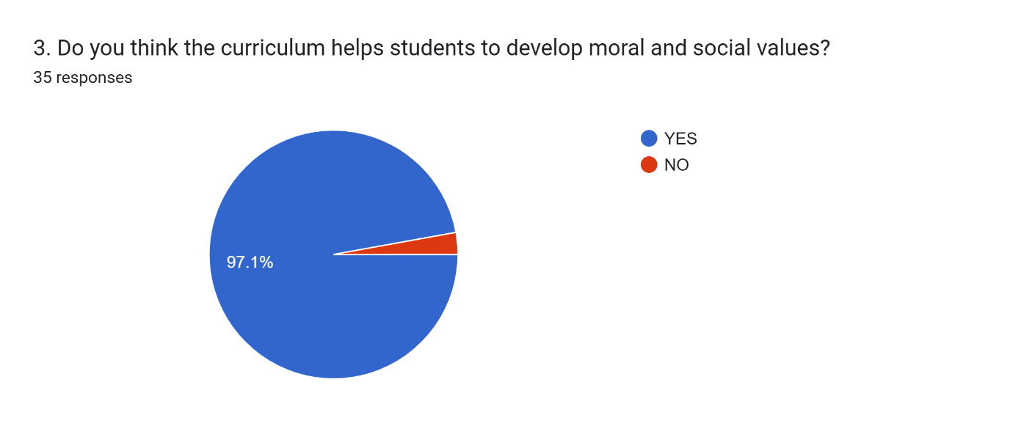
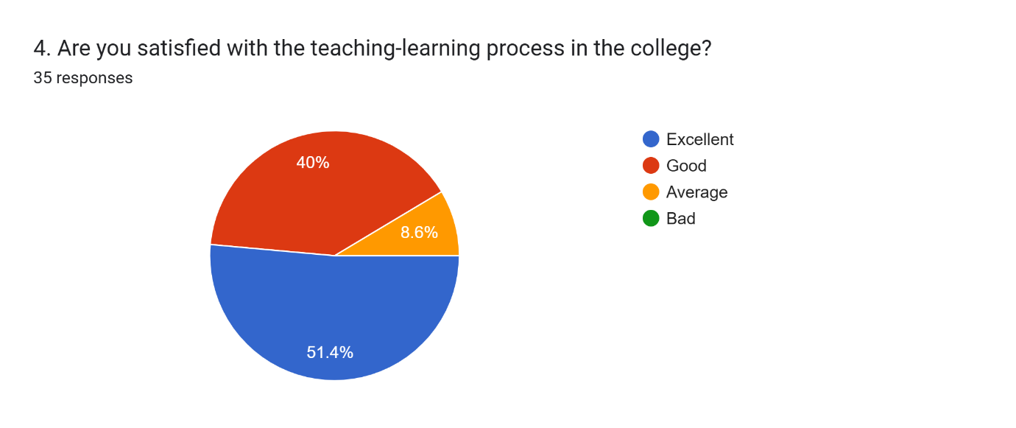
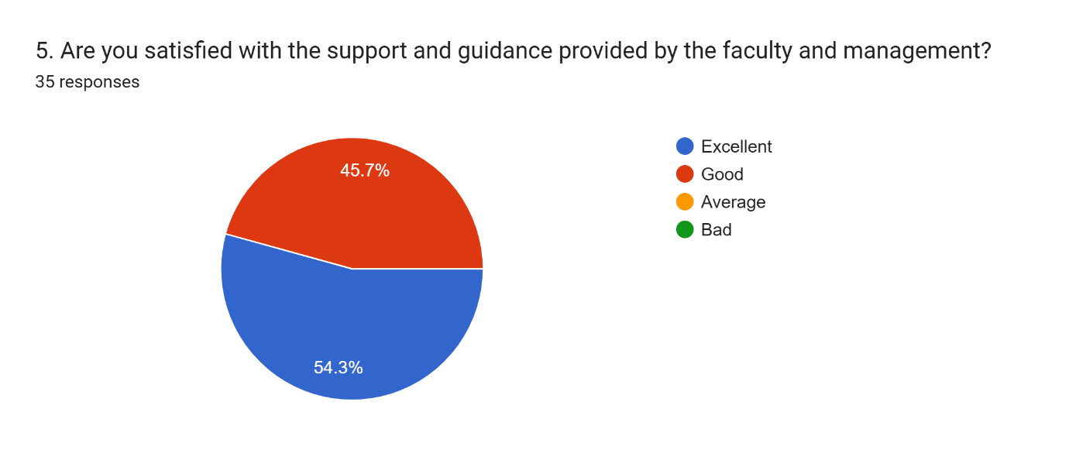
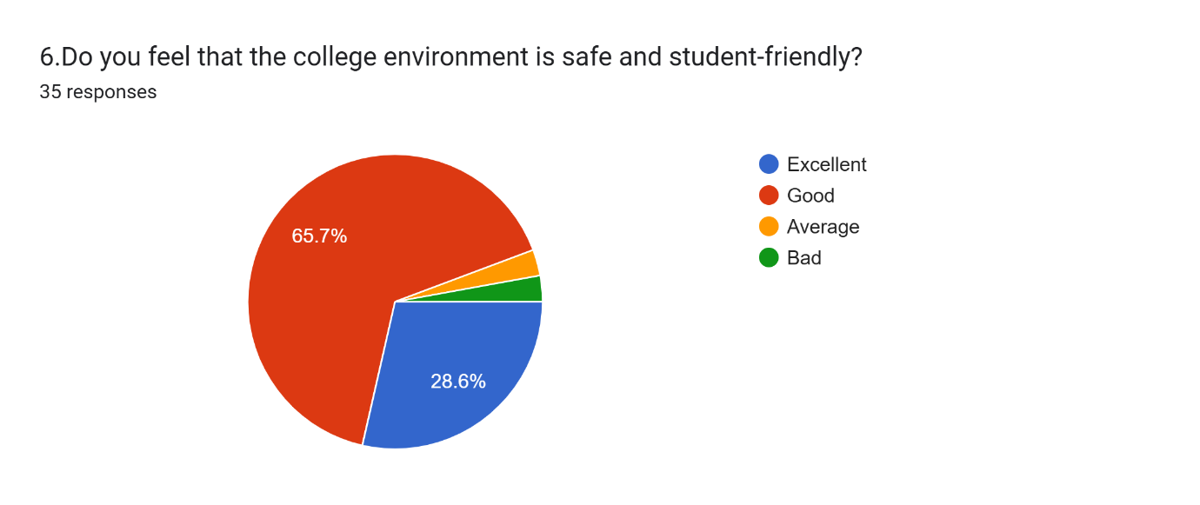
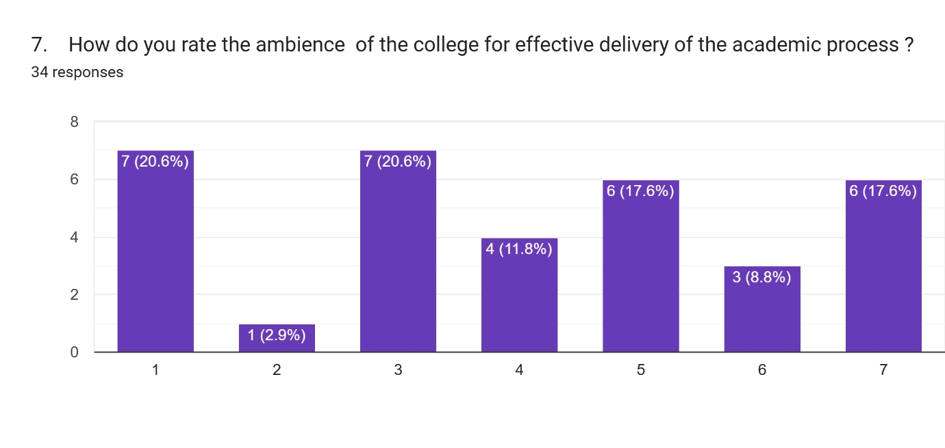
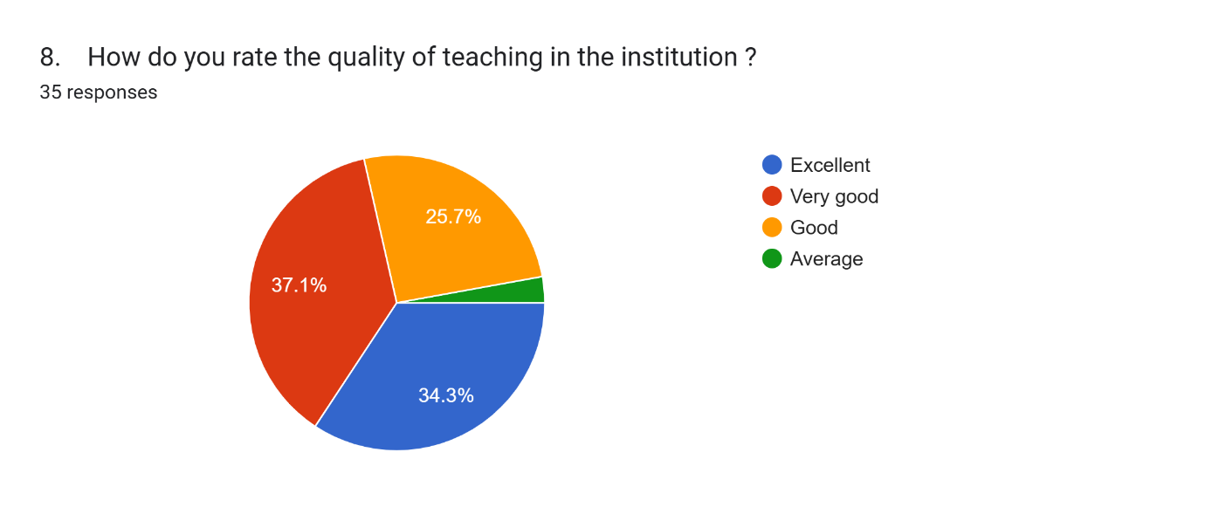
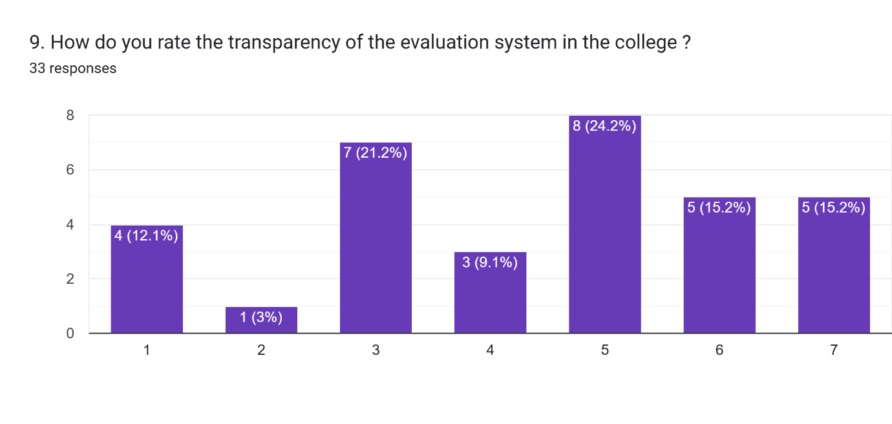
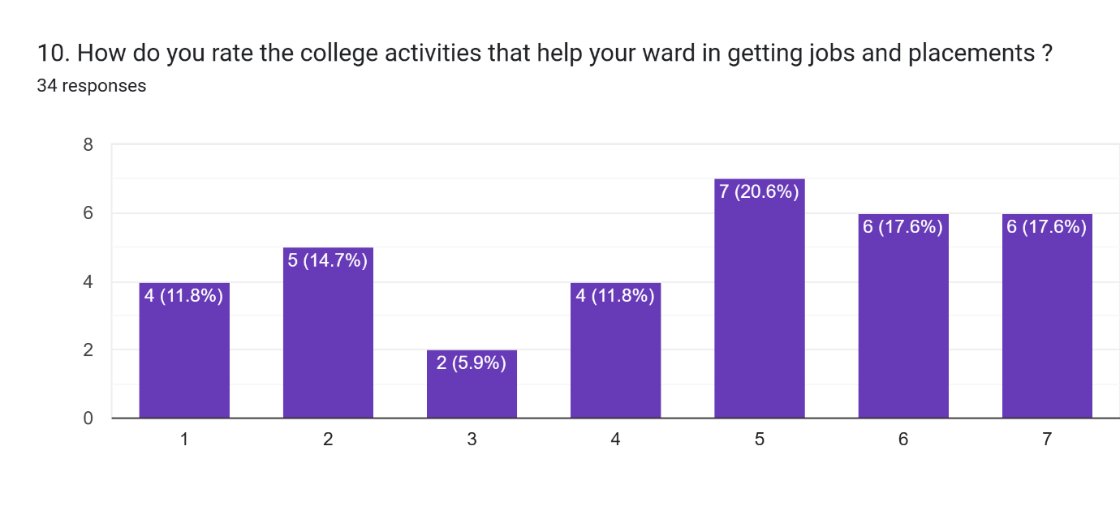

Consolidated Report on Parent Feedback (2025–26)
The overall parent feedback reflects a positive perception of the institution. Most parents expressed satisfaction with the quality of education, teaching methods, and the supportive attitude of the faculty. The college is appreciated for maintaining discipline, providing a safe learning environment, and encouraging students’ academic growth.
Parents also acknowledged the efforts of the institution in organizing academic and co-curricular activities that contribute to the overall development of students. Communication between the college and parents is considered satisfactory, though a few parents suggested more frequent updates regarding student progress.
Some suggestions were received regarding improvement in infrastructure, career guidance, and placement opportunities. Overall, the feedback indicates that the institution is performing well while also highlighting areas for further enhancement.

